# LSS & BEVDet Profile

## LSS(Lift, Splat, Shoot)

### Introduction

* 模型输入：来自6个camera的image(下图左侧),相机内外参数

* 模型输出：BEV视角下的语义分割，vehicle(**blue**)、drivable area (**orange**)、lane segmentation (**green**)

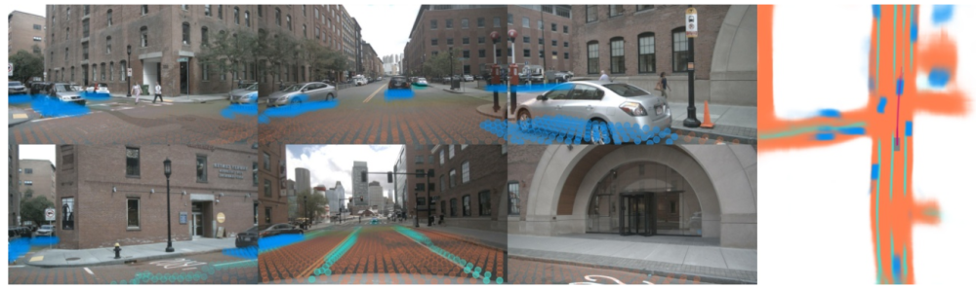

### Model design

* 从nuscenes数据集中加载某个sample的6张RGB图像，经过数据增强后变为(batch_size，6，3，128，352)

* 通过efficientnet-b0提取特征，并离散化为伪点云

* + 对feature map上的每个pixel预测一个深度分布与语义特征

* + 深度分布与语义特征outer product，形成伪点云数据

* 参照pointpillars讲点云变换为BEV视角

* 通过resnet18提取BEV视图特征后进行预测

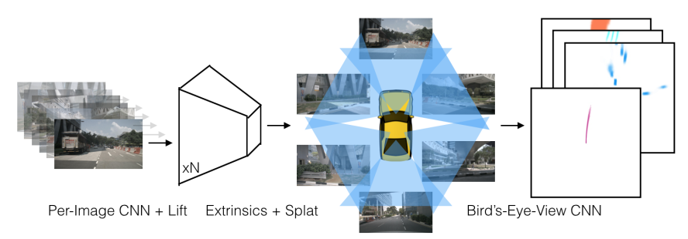

### Flops summary & Experiment

Lift,Splat,Shoot:

GTX1080、thop计算Param和GFLOPs

|  |  |  |  |  |  |  |  |
| --- | --- | --- | --- | --- | --- | --- | --- |
| **Cam Encoder** | **BEV Encoder** | **Input Size** | **Param** | **GFLOPs** | **IOU(Vehicle)** | **CheckPoint** | **可视化** |
| Efficientnet-b0 | Resnet18 | (6, 3, 256, 704) | 9.1M | 47.1 | 37.81 | [📎model_efb0_37.81.pt](https://yuque.antfin.com/attachments/lark/0/2022/pt/21256453/1654502360360-fdb715ee-56aa-4088-b5bb-2ae78ce09761.pt) | [📎Model-37.81.zip](https://yuque.antfin.com/attachments/lark/0/2022/zip/21256453/1654502360327-8ef609a1-d3cd-4aec-9284-b69cb0cf9ff4.zip) |
| (6, 3, 128, 352) | 9.1M | 35.3 | 32.81 | OpenSource | [📎OpenSource-Green.zip](https://yuque.antfin.com/attachments/lark/0/2022/zip/21256453/1654502360339-cb316003-8cc7-45e4-ae83-8594ba0b0603.zip)[📎mixed_gt_op_green.zip](https://yuque.antfin.com/attachments/lark/0/2022/zip/21256453/1654502360330-fdf24d2c-37ce-470e-b521-758e96f86252.zip) |
| Efficientnet-b3 | Resnet18 | (6, 3, 128, 352) | 9.5M | 35.7 | 34.28 | [📎model_efb3_34.28.pt](https://yuque.antfin.com/attachments/lark/0/2022/pt/21256453/1654502360333-705a7336-52fb-4c4a-9fbd-7c9dce17b79b.pt) |  |
| Efficientnet-b5 | Resnet18 | (6, 3, 128, 352) | 10.4M | 36.5 | 35.63 | [📎model_efb5_35.63.pt](https://yuque.antfin.com/attachments/lark/0/2022/pt/21256453/1654502360611-b1472132-ea74-43a7-99a1-9d9e74a841bc.pt) |  |
| Resnet50 | (6, 3, 384, 1056) |  |  | 36.71 |  |  |

# 输入分辨率: 128 * 352 相机内参关键参数  
Augmentation_Conf = {'resize_lim': (0.193, 0.225),   
 'final_dim': (128, 352),   
 'rot_lim': (-5.4, 5.4),   
 'H': 900,   
 'W': 1600,   
 'rand_flip': True,   
 'bot_pct_lim': (0.0, 0.22),   
 'cams': ['CAM_FRONT_LEFT', 'CAM_FRONT', 'CAM_FRONT_RIGHT', 'CAM_BACK_LEFT', 'CAM_BACK', 'CAM_BACK_RIGHT'],   
 'Ncams': 5}

### BEVDet Result

对比LSS和BEVDet两者基本一样，只是将LSS的BEV Encoder后的Head换成了检测头，具体对比如下:

